**Assignment 10**

**Swapnil Shashikant Kamate**

Problems:

35: Modify the MODEL table to add the attribute and insert the values shown in the following table.

**Answer:**

ALTER TABLE MODEL

ADD COLUMN MOD_WAIT_CHG INT;

UPDATE MODEL

SET MOD_WAIT_CHG = 100

WHERE MOD_CODE = 'C-90A';

UPDATE MODEL

SET MOD_WAIT_CHG = 50

WHERE MOD_CODE = 'PA23-250';

UPDATE MODEL

SET MOD_WAIT_CHG = 75

WHERE MOD_CODE = 'PA31-350';

36: Write the queries to update the MOD_WAIT_CHG attribute values based on Problem 35.

**Answer:**

UPDATE MODEL

SET MOD_WAIT_CHG = 100

WHERE MOD_CODE = 'C-90A';

UPDATE MODEL

SET MOD_WAIT_CHG = 50

WHERE MOD_CODE = 'PA23-250';

UPDATE MODEL

SET MOD_WAIT_CHG = 75

WHERE MOD_CODE = 'PA31-350';

37. Modify the CHARTER table to add the attributes shown in the following table.

**Answer:**

ALTER TABLE CHARTER

ADD COLUMN CHAR_WAIT_CHG FLOAT(8),

ADD COLUMN CHAR_FLT_CHG_HR FLOAT(8),

ADD COLUMN CHAR_FLT_CHG FLOAT(8),

ADD COLUMN CHAR_TAX_CHG FLOAT(8),

ADD COLUMN CHAR_TOT_CHG FLOAT(8),

ADD COLUMN CHAR_PYMT FLOAT(8),

ADD COLUMN CHAR_BALANCE FLOAT(8);

38. Write the sequence of commands required to update the CHAR_WAIT_CHG attribute values in the CHARTER table. (Hint: Use either an updatable view or a stored procedure.)

**Answer:**

UPDATE CHARTER

SET CHAR_WAIT_CHG = (

SELECT MOD_WAIT_CHG

FROM MODEL, AIRCRAFT

WHERE MODEL.MOD_CODE = AIRCRAFT.MOD_CODE

AND AIRCRAFT.AC_NUMBER = CHARTER.AC_NUMBER

) ;

39. Write the sequence of commands required to update the CHAR_FLT_CHG_HR attribute values in the CHARTER table. (Hint: Use either an updatable view or a stored procedure.)

**Answer:**

UPDATE CHARTER

SET CHAR_FLT_CHG_HR = (

SELECT MOD_CHG_MILE

FROM MODEL, AIRCRAFT

WHERE MODEL.MOD_CODE = AIRCRAFT.MOD_CODE

AND AIRCRAFT.AC_NUMBER = CHARTER.AC_NUMBER

) ;

40. Write the command required to update the CHAR_FLT_CHG attribute values in the CHARTER table.

**Answer:**

UPDATE CHARTER

SET CHAR_FLT_CHG = CHAR_HOURS_FLOWN * CHAR_FLT_CHG_HR;

41. Write the command required to update the CHAR_TAX_CHG attribute values in the CHARTER table.

**Answer:**

UPDATE CHARTER

SET CHAR_TAX_CHG= CHAR_FLT_CHG * (0.08);

42. Write the command required to update the CHAR_TOT_CHG attribute values in the CHARTER table.

**Answer:**

UPDATE CHARTER

SET CHAR_TOT_CHG= CHAR_FLT_CHG + CHAR_TAX_CHG;

43. Modify the PILOT table to add the attribute shown in the following table.

**Answer:**

ALTER TABLE PILOT

ADD COLUMN PIL_PIC_HRS FLOAT(8);

**Five LeetCode Problems:**

1. Write a SQL query to find employees who earn the top three salaries in each of the department. For the above tables, your SQL query should return the following rows (order of rows does not matter).

**Answer:**

select

x.Name as Department,

a.Name as Employee,

a.Salary as Salary

from Employee a

join (select distinct DepartmentId, Salary from Employee) b

on a.DepartmentId = b.DepartmentId and a.Salary <= b.Salary

join Department x

on a.DepartmentId = x.Id

group by a.DepartmentId, a.Name, a.Salary

having count(a.Salary) <= 3;

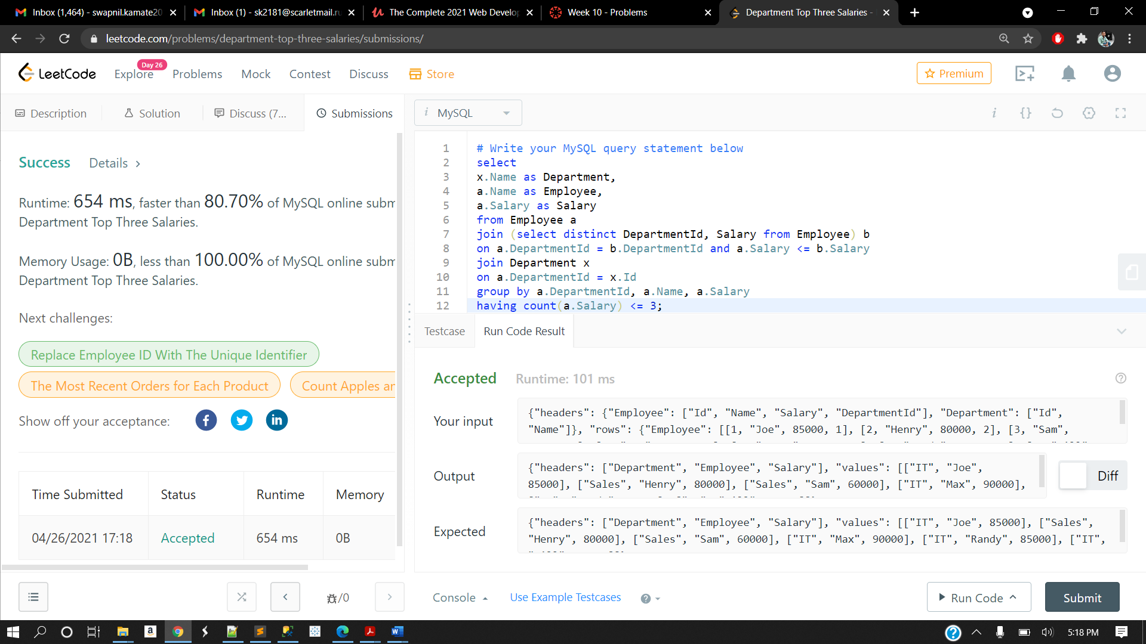

1. Write a SQL solution to output big countries' name, population and area.

**Answer:**

SELECT

name, population, area

FROM

world

WHERE

area > 3000000 OR population > 25000000;

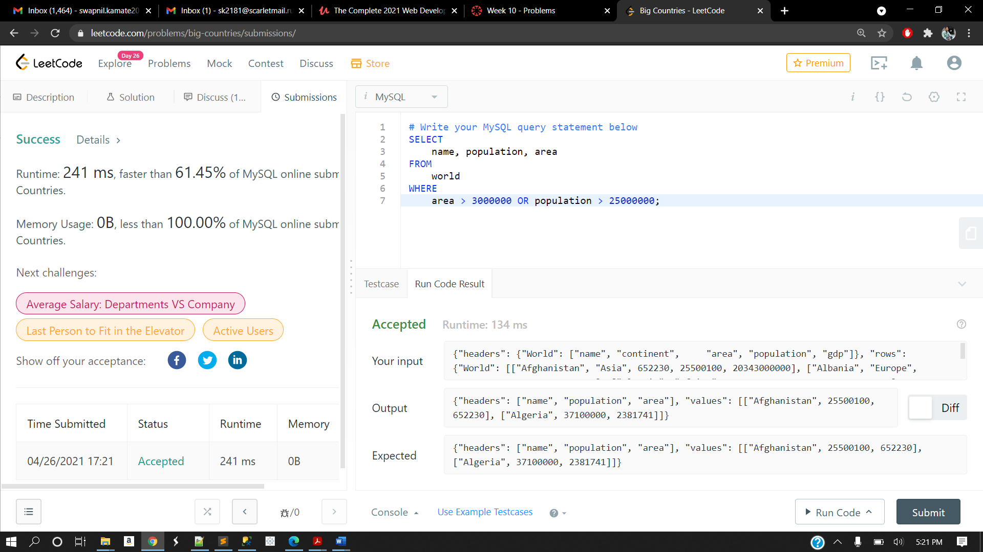

1. Mary is a teacher in a middle school and she has a table seat storing students' names and their corresponding seat ids. The column **id** is continuous increment. Mary wants to change seats for the adjacent students. Can you write a SQL query to output the result for Mary?

Answer:

SELECT s1.id - 1 as id, s1.student

FROM Seat s1

WHERE s1.id MOD 2 = 0

UNION

SELECT s2.id + 1 as id, s2.student

FROM Seat s2

WHERE s2.id MOD 2 = 1 AND s2.id != (SELECT MAX(id) FROM Seat)

UNION

SELECT s3.id, s3.student

FROM Seat s3

WHERE s3.id MOD 2 = 1 AND s3.id = (SELECT MAX(id) FROM Seat)

ORDER BY id ASC;

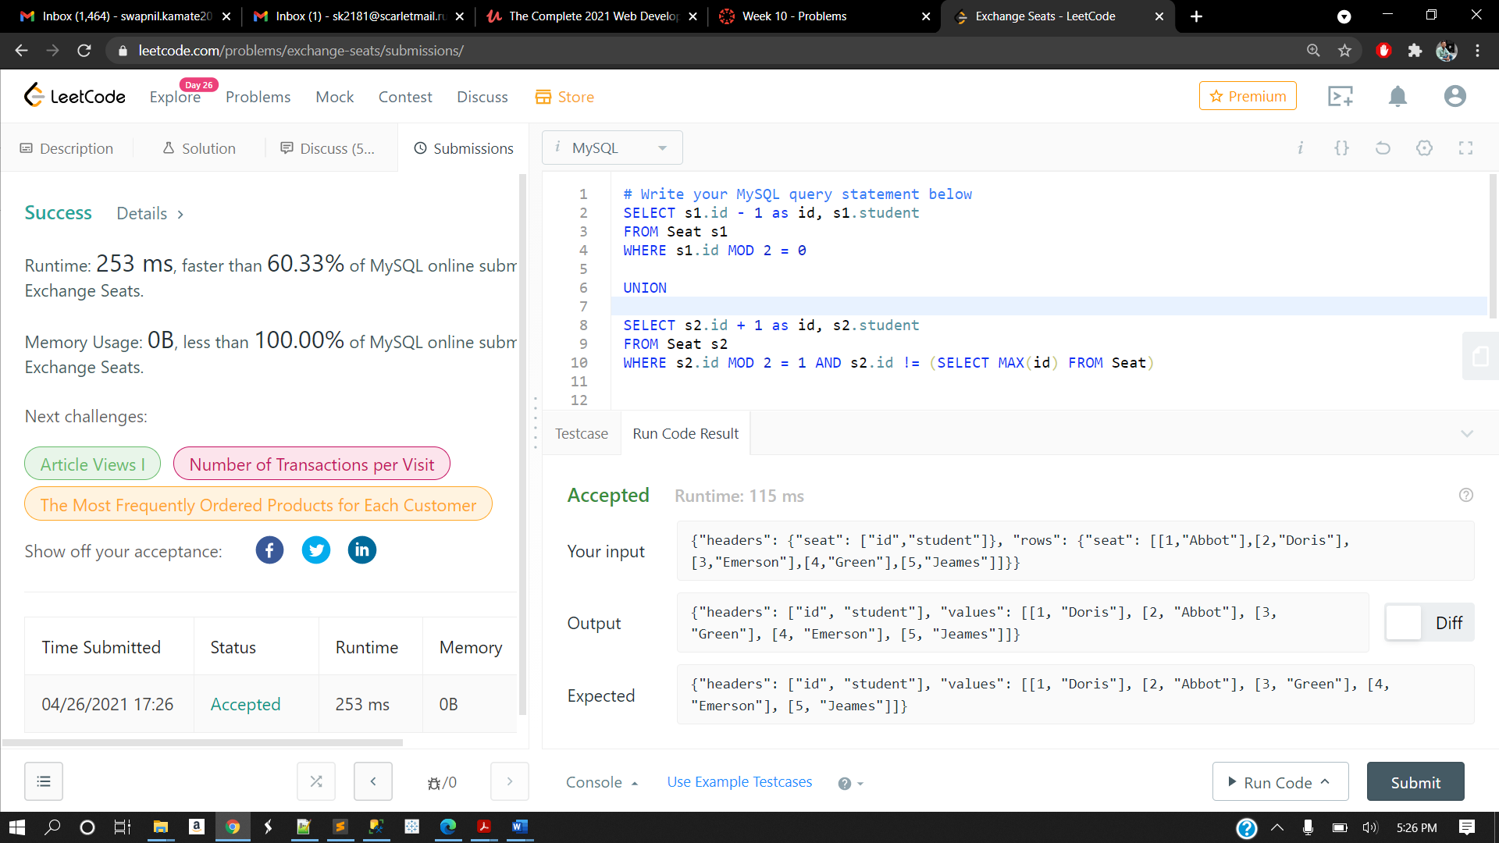

**4)** X city opened a new cinema, many people would like to go to this cinema. The cinema also gives out a poster indicating the movies’ ratings and descriptions.

Please write a SQL query to output movies with an odd numbered ID and a description that is not 'boring'. Order the result by rating.

**Answer:**

SELECT id, movie, description, rating

FROM cinema

WHERE id % 2 = 1 and description != "boring"

ORDER BY rating DESC

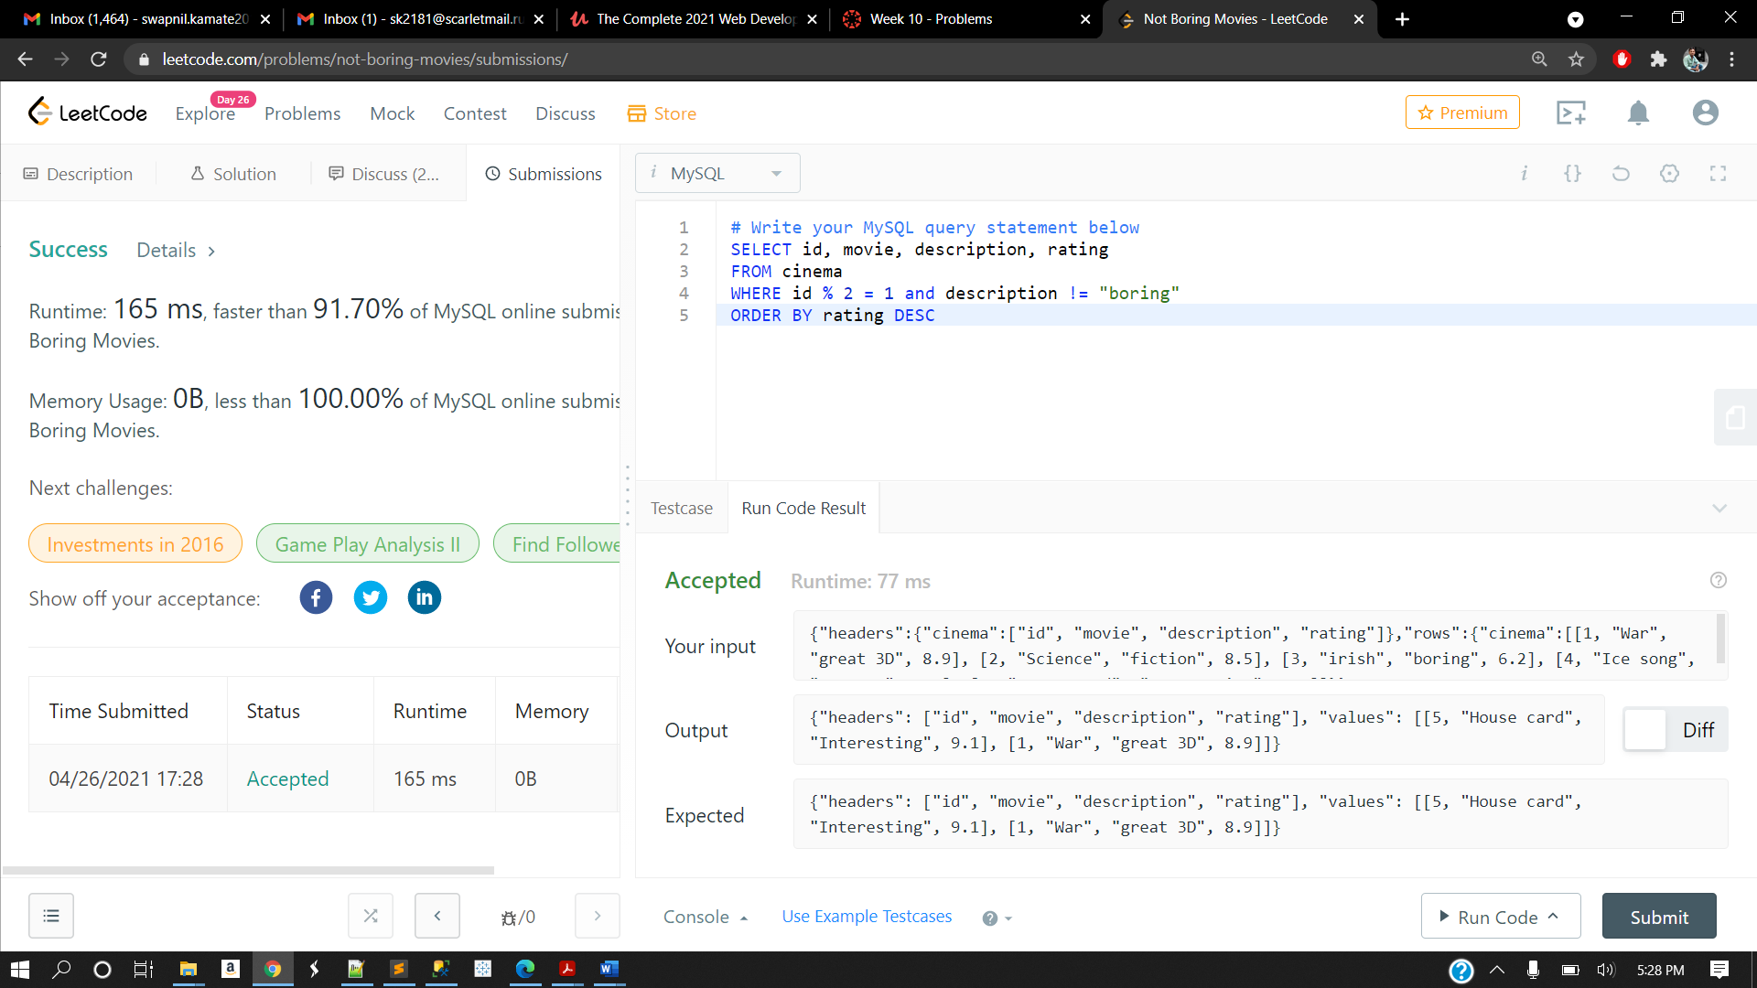

5)

write a SQL query that finds out employees who earn more than their managers. For the above table, Joe is the only employee who earns more than his manager.

Answer:

select e.name as Employee

from Employee e

inner join Employee m

on e.managerId = m.id

where e.salary > m.salary

